Main Image (required)
Main Image Object * | Confirm you have the rights to publish this image by typing “Yes” > | YES
Source URL * | https://www.pexels.com/photo/blue-peacock-45911/
Thumbnail | 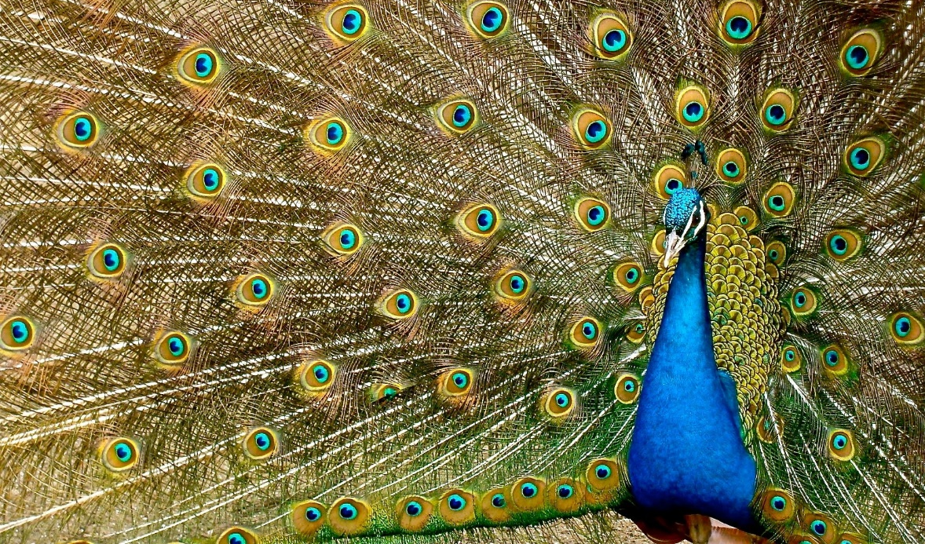
Credit Label | Photo by Pixabay:
Credit URL | https://www.pexels.com/@pixabay/
Author
New Author Object
Full Name * | Rawdyn Nutting
Internal * | No – if external, supply image. Minimum dimension 50px.  
Description
Links (label URL) | @codebase https://codebase.com.au/about/  LinkedIn https://www.linkedin.com/in/rawdyn/
SOURCE
Source Object: Used when the article is sourced from another website or origin or to show your own brand.
Name * | codebase
Logo | Via https://codebase.com.au/
Link * | https://codebase.com.au/
Label
Restricted | No

Title (required)
Article Example: Using the Static Article Repository (SAR)
Subtitle

Explore the options available for creating articles in the SAR system.
Body (required)

How does the article system work?
Articles are drawn from client content stored in json files or in a database or available via Content Delivery Networks (CDNs).
In their simplest form, Articles have only three requirements as well as many optional elements.
This article is divided into two sections. Section 1 talks about the options and settings. Section 2 looks at the elements and styles.

1. Options & Settings

Required Elements:
- Title.
This forms the title at the top of the body of text and is normally used to derive the URL. The URL can also be set explicitly.
- Image.
The main image is displayed at the top of the article and on the Article Tiles.
- Body.
The body of the article can be made up of many types of content including simple text, html blocks, video, audio, lists and more. Customisations can also be created for very specific output needs.

Advanced Options:
There are many other options you can leverage in creating articles. These include:
URL
Normally derived from the Title and formatted to be Search Engine friendly, this value can also be set explicitly. For example, if your title is “Our Latest Product Updates” then the URL would be <your-domain>/articles/our-latest-product-updates/ but you might want to explicitly set the URL to be, say, <your-domain>/articles/product-update/.
Publish Date (Time)
Provided in the format YYYY-MM-DD (hh:mm), this defaults to the article publish date but can be set explicitly. The time segment is optional.
Tags
Used when the Article Filter functionality is activated. On the articles grid, the filter allows users to filter down the articles to a subset based on the tags set on each article. You can set none, one or multiple tags on each article. The system will read all tags on all articles to produce the filter options so keep it to a limited set.
Keywords
Include a list of Keywords for use in building the Structured Data element consumed by the Google crawler. Keep them very relevant to the article and concise.
Label
This is shown on the Sitemap page and is designed to be a shortened version of the title where the full title woud be cumbersome to show.
Subtitle
This appears under the title and offers a way to expand on the title. There is only one Subtitle per page.
Snippet
This appears on the article Tile and if not set explicitly, defaults to the first paragraph of Body text.
Source
Where an article has been sourced from another website or origin, you can specify the source using a Source Object. This includes Name, Logo (image, SVG or link), Link, Label and restricted flag (set to 'yes' when you dont have explicit permission to publish the article on your website).
Author
For existing or internal (a team member that has a profile page on your website) Authors, just specify their full Name. For New Authors, use the New Author Object to declare their Full Name, Whether they are Internal or External (and an image if External), a Description and list of links (Label & URL for each).
Call to Action
The Call-to-Action (CTA) can appear at the foot of an Article. It provides a button link to a URL. It requires a URL and may also have a Heading, Body, Icon, and Label.
Meta Title
The Meta Title is an HTML element that specifies the title of a web page. A page’s title tag is displayed as part of the search snippet in a search engine results page (SERP). It appears as the clickable headline for the search result and is important for user experience, SEO, and social sharing. The title tag of a web page is meant to be an accurate and concise description of a page's content.
The optimal length of a Meta Title is 50-60 characters. For more information and a tool to help you optimise the Meta Title, please visit moz.com.
Meta Description
A meta description is an HTML element that provides a brief summary of a web page. A page’s meta description tag is displayed as part of the search snippet in a search engine results page (SERP) and is meant to give the user an idea of the content that exists within the page and how it relates to their search query.
The Meta Description is truncated after about 160 characters so keep it between 50 and 160 characters.

2. Elements & Styles
It's best to develop a consistent styling for your articles. Variations in style may require we customise your content delivery each time you submit an article.
This doesn't mean you should feel confined. If you need to use new styles then we can help you manage your article styles to keep it manageable.
Below are your default styles which you will find in your MS Word Template.

Section Heading 1

Section Heading 2
Section Heading 3
This is a simple paragraph. If you regularly need a specific style alternative, we can easily create that for you.
Below is a simple unordered list...
- Option One
- Option Two
- Option Three
Below is a unordered list which includes subtle, extended descriptions for each option.
Please note: due to limitations in MS Word style settings, your MS Word Template does not include an exact style for this result. It can be achieved by pressing 'Shift' & 'Return' after each item to then add the detailed descriptions without starting another bulleted item.
- Option One
Reprehenderit veniam qui magna nostrud consequat aliqua eiusmod mollit ea eu aute. Laboris sint ea exercitation proident ullamco labore ad occaecat cupidatat in aliquip duis.
- Option Two
Irure incididunt ea laboris sit dolor qui Lorem sunt. Ex labore commodo veniam proident pariatur voluptate do nisi ullamco. Reprehenderit magna est culpa reprehenderit fugiat.

Quote Example
Life is what happens to us while we are making other plans.
Allen Saunders 1957

Audio Example
article-example-this-is-the-bbc.mp3

YouTube Example
https://youtu.be/qWJTUAezxAI

Image Example
You can also nest images in the body of an article.
Image Object | Confirm you have the rights to publish this image by typing “Yes” > | YES
Source URL * | https://www.pexels.com/photo/big-ben-bridge-castle-city-460672/
Thumbnail | 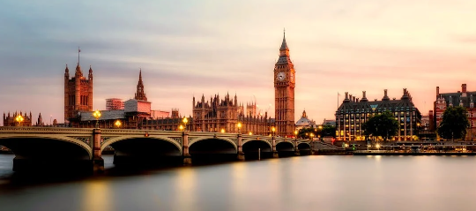
Caption | View across the Thames at the Houses of Parliament and Elizabeth Tower
Credit Label | Photo by Pixabay
Credit URL | https://www.pexels.com/@pixabay/

In the end we can accommodate any requirements and styling needs as the article is as customisable as any web page. Keep in mind, customisations can take time and there may be, depending on their complexity, some costs in that process.
Call to action
Call to Action Object
Heading | Download this Article Template
Body | See how this article was constructed in the MW Word template.
Label | Download MS Word
Icon | IconMSWord
URL * | File Article-Example-Template-V01.docx is this document.
Other Options
URL | article-example
Publish Date | 2018-12-17
Tags | Hint
Keywords
Label | Article Example: Using SAR
Snippet | A quick overview of the Article System options & settings.

